|  |  |  |  |
| --- | --- | --- | --- |
| |  |  | | --- | --- | | **Logo_FPT_University_doc** | **MINISTRY OF EDUCATION AND TRAINING** |   **FPT UNIVERSITY**   |  | | --- | | Capstone Project | |
|  |
| Cook them all  Report 3: Software Requirements Specifications |
| |  |  | | --- | --- | | **S.O.B TEAM** | | | **Group Members** | Trần Trung Kiên - 01017  Đặng Xuân Toàn - 01143  Trần Sỹ Tùng - 01302  Bùi Trung Kiên - 01359  Ngô Thị Việt Anh - 01286 | | **Supervisor** | Huỳnh Anh Dũng | | **Ext Supervisor** | Nguyễn Tất Trung | | **Capstone Project code** | CTA\_v1.0 | |
|  |

- Hanoi, 5/2012 -

Contents

[I. User Requirement Specification 3](#_Toc332877724)

[1. User Requirements 3](#_Toc332877725)

[2. Administration Requirements 3](#_Toc332877726)

[3. Ranking requirements 4](#_Toc332877727)

[4. Comment/Answer requirements 4](#_Toc332877728)

[5. Cooking Recipe Requirements 5](#_Toc332877729)

[6. Search Requirements 5](#_Toc332877730)

[II. System Requirement Specification 5](#_Toc332877731)

[1. External Interface Requirements 5](#_Toc332877732)

[1.1 User Interfaces 6](#_Toc332877733)

[1.2 Hardware Interfaces 6](#_Toc332877734)

[1.3 Software Interfaces 6](#_Toc332877735)

[1.4 Communications Protocol 6](#_Toc332877736)

[2. System Features 7](#_Toc332877737)

[2.1 Back – end 7](#_Toc332877738)

[2.1.1. Account Management 7](#_Toc332877742)

[2.1.2. Category Management 14](#_Toc332877743)

[2.1.3. Recipe Management 22](#_Toc332877744)

[2.1.4. Report Management 27](#_Toc332877745)

[2.1.5. Approval 31](#_Toc332877746)

[2.1.6. Dictionary Management 35](#_Toc332877747)

[2.2 Front – end 41](#_Toc332877748)

[2.2.1. Account Information 41](#_Toc332877749)

[2.2.2. Comment 50](#_Toc332877750)

[2.2.3. Create 53](#_Toc332877751)

[2.2.4. Personal Information 61](#_Toc332877752)

[2.2.5. Question & Answer 66](#_Toc332877753)

[2.2.6. Rate Content 73](#_Toc332877754)

[2.2.7. Favorite List 75](#_Toc332877755)

[2.2.8. Search 82](#_Toc332877756)

[2.2.9. Share Contents 84](#_Toc332877757)

[2.2.10. Sort Content 86](#_Toc332877758)

[2.2.11 Personal Contribution 88](#_Toc332877759)

[2.2.12 Dictionary 89](#_Toc332877760)

[3. Software System Attributes 93](#_Toc332877761)

[3.1 Usability 93](#_Toc332877762)

[3.2 Reliability 93](#_Toc332877763)

[3.3 Availability 94](#_Toc332877764)

[3.4 Security 94](#_Toc332877765)

[3.5 Maintainability 95](#_Toc332877766)

[3.6 Portability 95](#_Toc332877767)

[3.7 Performance 95](#_Toc332877768)

[3 Data Structures 96](#_Toc332877769)

[1. Data schema 96](#_Toc332877770)

[2. Folder Structure 96](#_Toc332877771)

[3. Description 96](#_Toc332877772)

[4 References 97](#_Toc332877773)

# User Requirement Specification

## User Requirements

* User can create accounts on the website. Email address and password are required for registering an account on the website. 1 email address can only be used once for registering.
* User can edit his/her account information: Display Name, Avatar, and Password. But he/she can’t change his/her email address which was used for registering.
* User can change password which was registered in case he/she forgot it. Change Password link will be in content of email sent to user. This link will open Change Password page for user.
* User can change his/her password through his/her User Profile page.
* User can see his/her account information and other’s.
* User can see other user’s statistic like: Display Name, Registered Date, number of created recipes, number of posted comments, questions and answers.
* User can search for contents by using Quick Search and Advanced Search
* User can view information of recipes, rate the recipes, add it to favorites list, share it on social networks (Twitter and Facebook) or report it as spam.
* User can upload images for recipes.
* User can view his/her favorites list and remove recipes from the list at his/her profile page.
* User can see list of questions, recipes he/she posted at his/her profile page.
* User can write comments for recipes or delete it.
* User can thumb up, thumb down or report comments of other users but his/her comments
* User can create recipes and edit his/her recipes.
* User can approve and edit recipes of other users when they rank up in ranking system (has 10000 points and more) and have granted that privilege.
* User can view and post questions on Question & Answer page.
* User can answer to questions, thumb up, thumb down or report as it as spam.
* User can vote up, vote down or report other user’s answers.
* User can delete his/her answers.

## Administration Requirements

* Admin can view a list of all categories in the system, add new categories, edit categories and delete categories.
* Admin can view a list of all users in the system, view and edit user information, active users on the system or delete users.
* Admin can view a list of all advertisers on the website, add new ones, edit or delete advertises.
* Admin can view a list of spam reports, decide they are spam or not. Spam reports include reports about recipes, reports about comments, reports about questions, reports about answers and reports about recipes images.
* Admin can use all functions in the system.
* Admin can view a list of all recipes in the system, edit or delete these recipes.
* Admin can see list of contacts from users to administrators, view detail or delete.
* Admin can see statistics on the whole system: Registered User number, Activated User number, Comment number, Question number, Answer number, All the Time Visitor number, Today Visitor number, Online Visitor number.

## Ranking requirements

* User Point will be used in user ranking system of the website
* User Point is calculated as follow:
  + - * Starter point for every user is 10
      * Create a recipes: +30
      * Create a tip: +20
      * Create a news: +15
      * Max point per day: < 120
      * 1 time spam (any kind): - 25
* CP will be used to set rank for user:
* Phụ bếp: 0
* Đầu bếp tập sự: >100
* Đầu bếp chính thức: >500
* Đầu bếp trứ danh: >1000
* Bếp phó: >2000
* Bếp trưởng >3500
* Siêu đầu bếp >6000
* Vua đầu bếp: >10000
* 10 user who post most answers will be in on Most Contributors list in Q&A page
* There is a list for 20 Newest Questions at Q&A page and Home page.
* A list of 5 newest recipes, news and tips is displayed at home page by default.
* Every list is updated each 10 minutes.

## Comment/Answer requirements

* A comment/answer can’t be blank and must be less than 4000 characters.
* When the number of comments/answers is big, the comments/replies will be displayed each time 10 comments/answers. To see more comments/answers users need click to “Xem thêm”.
* 2 most voted up comments/answers will be highlighted and put on top of Comment Area/Answer Area. These highlighted comments/answers still can be treated as normal comments/answers.
* Each user can only post 1 comment for a recipe or 1 answer for a question each 3 minutes.

## Cooking Recipe Requirements

A cooking recipe has following information:

* Name (required)
* Main ingredient (required)
* Method (required)
* Kind (required)
* Description
* Number of view
* Rating
* Dish Images: include a main image displayed as the dish and other images display steps of recipe (1 image for 1 step).
* Steps: include steps from ingredient preparation to dish completion
* Suggestion List: 15 highest popularity recipes in the same category

## Search Requirements

There is a kind of search in the website:

This function provides users more options search. These options are:

* Search by keyword
* Search by category

# System Requirement Specification

## External Interface Requirements

### User Interfaces

* Interface need to attract the attention of users to the product image. Products are things having a lot of colors and diversity combination in order to attract users. Website should have the background simple, less color, less attention but that also shows clear boundaries between each section: photos with text, photos with photos, and photos with the background…So color choices should be pleasing to the eye and should stimulate the user's interest.
* Page layout and navigation should be as intuitive and easy as possible.
* The overuse of product images should not increase the time in which a page downloads, which has a negative impact on usability.

### Hardware Interfaces

Our website needs to run are the peripheral devices mouse and keyboard. System can display many image formats, such as: jpg, jpeg.

### Software Interfaces

* Products run on web application, it requires the use of programming languages supported on the browser.
* Outside, the system should use the program to manage resources data, this program can be combined with the system, can change and update from the system. Data products will be exchanged between systems and external data through data management software

|  |  |  |
| --- | --- | --- |
| Software name | Version | Source |
| .NET Framework | 4.0 | Microsoft |
| SQL Server | R2 | Microsoft |
| Visual Studio | 2010 | Microsoft |
| MVC | 3.0 | Microsoft |
| Enterprise Library |  | Microsoft |

### Communications Protocol

* The system uses the protocol http, https to call service from third parties such as: Google, Face book, Yahoo to authenticate users or share contents.
* System implemented on the browser, using standard protocols to communicate between users and server.
* In the process of communication, some important information of the user system will use the protocol https to transfer data.
* The system should produce nicely formatted HTML that popular social network such as Face book, Google+ can share information.

## System Features

### Back – end



#### Account Management

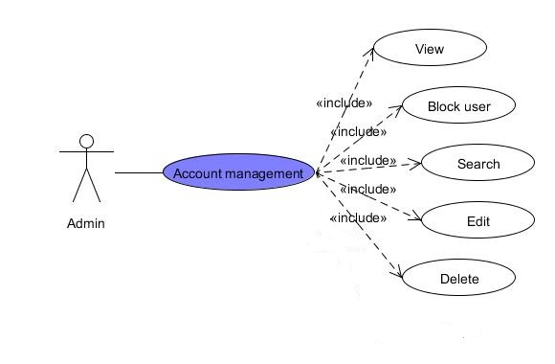

* + - 1. View Users

|  |  |  |  |  |
| --- | --- | --- | --- | --- |
| **USE CASE – View Users SPECIFICATION** | | | | |
| **Use-case No.** | UC001 | **Use-case Version** | | 1.0 |
| **Use-case Name** | View Users | | | |
| **Author** | ToanDX | | | |
| **Date** | 03/06/2012 | **Priority** | High | |
| **Actor:**  Administrator  **Summary:**  Administrator can view all member and their detail information  **Goal:**  Allow administrator to list all users in website  **Triggers**  Click to “Users” menu then click to “Manage Users” sub menu  **Preconditions:**  Logged into the system with admin role and go to Admin page  **Post Conditions:**  Open manage user page  **Main Success Scenario:**   |  |  |  | | --- | --- | --- | | Step | Actor Action | System Response | | 1 | Click to “Users” menu then click to “Manage Users” sub menu | Display Manage User page with all user in the system | | 2 | Click to username hyperlink at Manage User page | Redirect to User Detail page |   **Alternative Scenario:**  N/A  **Exceptions:**  N/A  **Relationships:**  N/A  **Business Rules:**  N/A | | | | |

* + - 1. Ban An User

|  |  |  |  |  |
| --- | --- | --- | --- | --- |
| **USE CASE – Ban An User SPECIFICATION** | | | | |
| **Use-case No.** | UC002 | **Use-case Version** | | 1.0 |
| **Use-case Name** | Ban An User | | | |
| **Author** | ToanDX | | | |
| **Date** | 03/06/2012 | **Priority** | High | |
| **Actor:**  Administrator  **Summary:**  Administrator can ban user.  **Goal:**  Allow administrator to ban spam user or who have bad behavior in website  **Triggers**  Click to “Ban” from dropdown list  **Preconditions:**  Logged into the system with admin role and open User Detail page  **Post Conditions:**  Redirect back to Manage User page  **Main Success Scenario:**   |  |  |  | | --- | --- | --- | | Step | Actor Action | System Response | | 1 | Click to “Banned” from User state dropdown list |  | | 2 | Click to “Save” button | Redirect back to Manage User page. |   **Alternative Scenario:**   |  |  |  | | --- | --- | --- | | Step | Actor Action | System Response | | 1 | Click to “Banned” from User state dropdown list |  | | 3 | Click to “Cancel” button | Redirect back to Manage User page. |   **Exceptions:**  N/A  **Relationships:**  List of user use case  **Business Rules:**  N/A | | | | |

* + - 1. Edit An User

|  |  |  |  |  |
| --- | --- | --- | --- | --- |
| **USE CASE – Edit An User SPECIFICATION** | | | | |
| **Use-case No.** | UC003 | **Use-case Version** | | 1.0 |
| **Use-case Name** | Edit An User | | | |
| **Author** | ToanDX | | | |
| **Date** | 03/06/2012 | **Priority** | High | |
| **Actor:**  Administrator  **Summary:**  Administrator can edit existing member in system such as point, change user state or assign role.  **Goal:**  Allow administrator to update user profile.  **Triggers**  Click to “Edit” button  **Preconditions:**  Logged into the system with admin role and open User Detail page  **Post Conditions:**  Redirect back to manage user page  **Main Success Scenario:**   |  |  |  | | --- | --- | --- | | Step | Actor Action | System Response | | 1 | Click to “Edit” button | Redirect to Edit User page | | 2 | Change some information |  | | 3 | Click to “Save” button | Redirect to Manage User page |   **Alternative Scenario:**  N/A  **Exceptions:**   |  |  |  | | --- | --- | --- | | Step | Actor Action | System Response | | 1 | Click to “Edit” button | Redirect to Edit User page | | 2 | Leave required fields blank |  | | 3 | Click to “Save” button | Displayed error message inform admin can’t leave required fields blank |   **Relationships:**  View User Detail use case  **Business Rules:** | | | | |

* + - 1. Delete An User

|  |  |  |  |  |
| --- | --- | --- | --- | --- |
| **USE CASE – Delete An User SPECIFICATION** | | | | |
| **Use-case No.** | UC004 | **Use-case Version** | | 1.0 |
| **Use-case Name** | Delete An User | | | |
| **Author** | ToanDX | | | |
| **Date** | 03/06/2012 | **Priority** | High | |
| **Actor:**  Administrator  **Summary:**  Administrator can delete an user  **Goal:**  Allow administrator to delete spam user or who have bad behavior in website  **Triggers**  Click to “Delete” button  **Preconditions:**  Logged into the system with admin role and open User Detail page  **Post Conditions:**  Redirect back to Manage User page  **Main Success Scenario:**   |  |  |  | | --- | --- | --- | | Step | Actor Action | System Response | | 1 | Click to “Delete” button | Pop up confirm message “Are you sure you want to delete this User?” | | 2 | Click to “Ok” button | Popup close, redirect back to Manage User page, display message “User has been deleted successfully” |   **Alternative Scenario:**  N/A  **Exceptions:**  N/A  **Relationships:**  List of user use case  **Business Rules:**  N/A | | | | |

#### Category Management

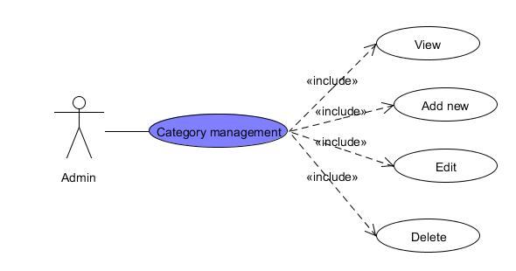

* + - 1. View Categories

|  |  |  |  |  |
| --- | --- | --- | --- | --- |
| **USE CASE – View Categories SPECIFICATION** | | | | |
| **Use-case No.** | UC005 | **Use-case Version** | | 1.0 |
| **Use-case Name** | View Categories | | | |
| **Author** | ToanDX | | | |
| **Date** | 03/06/2012 | **Priority** | High | |
| **Actor:**  Administrator  **Summary:**  Category is only be managed by administrator. A list of all categories in the system will be listed.  **Goal:**  Admin can view existed category list.  **Triggers**  Click to “Categories” menu then click to “Manage Categories” sub menu  **Preconditions:**  Successfully logged into the system with Admin role and go to Admin page  **Post Conditions:**  Categories List page will be displayed with all existed categories  **Main Success Scenario:**   |  |  |  | | --- | --- | --- | | Step | Actor Action | System Response | | 1 | Click to “Categories” menu then click to “Manage Categories” sub menu | Categories List page will be displayed with all existed categories |   **Alternative Scenario:**  N/A  **Exceptions:**  N/A  **Relationships:**  N/A  **Business Rules:**  N/A | | | | |

* + - 1. Create New Category

|  |  |  |  |  |
| --- | --- | --- | --- | --- |
| **USE CASE – Create new category SPECIFICATION** | | | | |
| **Use-case No.** | UC006 | **Use-case Version** | | 1.0 |
| **Use-case Name** | Create New Category | | | |
| **Author** | ToanDX | | | |
| **Date** | 03/06/2012 | **Priority** | High | |
| **Actor:**  Administrator  **Summary:**  Admin can create a new category in the system  **Goal:**  Create a new category in database.  **Triggers**  Click to “Categories” menu then click to “Create a new category” sub menu  **Preconditions:**  Successfully logged into the system with Admin role and go to admin page.  **Post Conditions:**  New category is added to database and displayed in Manage Category page.  **Main Success Scenario:**   |  |  |  | | --- | --- | --- | | Step | Actor Action | System Response | | 1 | Click to “Categories” menu then click to “Create a new category” sub menu | Redirect to Create Category page | | 2 | Enter needed information |  | | 3 | Click to “Save” button | Redirect to Manage Category page with new category was added and display message “Category has been inserted successfully” |   **Alternative Scenario:**  N/A  **Exceptions:**   |  |  |  | | --- | --- | --- | | Step | Actor Action | System Response | | 1 | Click to “Categories” menu then click to “Create a new category” sub menu | Redirect to Create Category page | | 2 | Leave Category name blank |  | | 3 | Click to “Save” button | Display message “Name is required.” |   **Relationships:**  Login use case  **Business Rules:**  N/A | | | | |

* + - 1. Edit Category

|  |  |  |  |  |
| --- | --- | --- | --- | --- |
| **USE CASE – Edit Category SPECIFICATION** | | | | |
| **Use-case No.** | UC007 | **Use-case Version** | | 1.0 |
| **Use-case Name** | Edit Category | | | |
| **Author** | ToanDX | | | |
| **Date** | 03/06/2012 | **Priority** | High | |
| **Actor:**  Administrator  **Summary:**  The admin can make a mistake when creating a new category. So he/she want to correct it. The admin can edit a category.  **Goal:**  Edit a category  **Triggers**  Click to “Edit” button  **Preconditions:**  Successfully logged into the system with Admin role and accessed to Manage Category page.  **Post Conditions:**  Redirect back to Manage Category page  **Main Success Scenario:**   |  |  |  | | --- | --- | --- | | Step | Actor Action | System Response | | 1 | Click to “Edit” button | Redirect to Edit Category page | | 2 | Edit information |  | | 3 | Click to “Save” button | Redirect back to Manage Category page and display message “Category has been updated successfully” |   **Alternative Scenario:**  N/A  **Exceptions:**   |  |  |  | | --- | --- | --- | | Step | Actor Action | System Response | | 1 | Click to “Edit” button | Redirect to Edit Category page | | 2 | Leave Name blank |  | | 3 | Click to “Save” button | Display message “Có lỗi xảy ra. Thực hiện tác vụ không thành công.” |   **Relationships:**  Login use case, List all category use case  **Business Rules:**  N/A | | | | |

* + - 1. Delete Category

|  |  |  |  |  |
| --- | --- | --- | --- | --- |
| **USE CASE – Delete Category SPECIFICATION** | | | | |
| **Use-case No.** | UC008 | **Use-case Version** | | 1.0 |
| **Use-case Name** | Delete Category | | | |
| **Author** | ToanDX | | | |
| **Date** | 03/06/2012 | **Priority** | High | |
| **Actor:**  Administrator  **Summary:**  When the admin see a category which category is useless, they can want to delete it.  **Goal:**  Delete categories in database.  **Triggers**  Click to “Delete” button.  **Preconditions:**  Successfully logged into the system with Admin role and accessed to Manage Category page.  **Post Conditions:**  Stay remains at Manage Category page and selected category will be deleted from category list.  **Main Success Scenario:**   |  |  |  | | --- | --- | --- | | Step | Actor Action | System Response | | 1 | Click to “Delete” button | Pop up a window to confirm if the admin really want to delete the category. | | 3 | Click to “OK” button | Redirect to Manage Categories page with selected category was removed from the list and display message “Category has been deleted successfully” |   **Alternative Scenario:**  N/A  **Exceptions:**  N/A  **Relationships:**  Login use case  **Business Rules:**  N/A | | | | |

#### Recipe Management

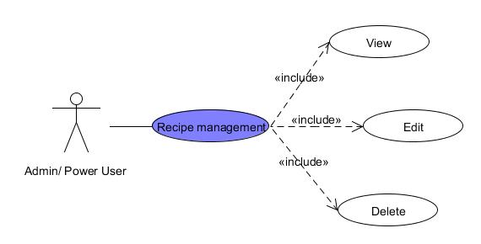

* + - 1. View recipe

|  |  |  |  |  |
| --- | --- | --- | --- | --- |
| **USE CASE – View Recipe SPECIFICATION** | | | | |
| Use-case No. | UC09 | Use-case Version | | 1.0 |
| Use-case Name | View recipe | | | |
| Author | KienBT | | | |
| Date | 02/06/2012 | Priority | Normal | |
| **Actor:**  Admin/Power user  **Summary:**  When Admin or Power user wants to view posted recipes  **Goal**  Admin or power user can view posted recipes  **Triggers**  Click to “Recipe Management” menu then click to “View” sub menu  **Preconditions:**  Logged into website with Admin or Power user role successfully.  **Post Conditions:**  N/A  **Main Success Scenario:**   |  |  |  | | --- | --- | --- | | Step | Actor Action | System Response | | 1 | Click to “Recipe Management” menu then click to “View” sub menu | Navigate user to the page with list of existed recipes |   **Alternative Scenario:**  N/A  **Exceptions:**  N/A  **Relationships:**  Login use case  **Business Rules:**  Must be admin or power user to view recipe management | | | | |

* + - 1. Edit recipe

|  |  |  |  |  |
| --- | --- | --- | --- | --- |
| **USE CASE – Edit Recipe SPECIFICATION** | | | | |
| Use-case No. | UC10 | Use-case Version | | 1.0 |
| Use-case Name | Edit recipe | | | |
| Author | KienBT | | | |
| Date | 02/06/2012 | Priority | High | |
| **Actor:**  Admin / Power user  **Summary:**  When Admin or Power User finds something wrong in a recipe, such as misspellings, missing tags. They edit the recipe for better.  **Goal**  Admin or power user can edit posted recipes  **Triggers**  Click to “Recipe Management” menu then click to “View” sub menu  **Preconditions:**  Logged into website with Admin or Power user role successfully.  **Post Conditions:**  N/A  **Main Success Scenario:**   |  |  |  | | --- | --- | --- | | Step | Actor Action | System Response | | 1 | Click to “Recipe Management” menu then click to “View” sub menu | Navigate admin to the page with list of existed recipes | | 2 | Click to the recipe admin wants to edit | Navigate admin to the page with corresponding detailed recipe. | | 3 | Click to “Edit” button at the bottom of post | Change post to edit form | | 4 | Click to textboxes, combo boxes and type to edit. |  | | 5 | Click to “Save” button at the bottom of form | Display message “Recipe edited successfully” |   **Alternative Scenario:**  N/A  **Exceptions:**   |  |  |  | | --- | --- | --- | | Step | Actor Action | System Response | | 1 | Click to “Recipe Management” menu then click to “View” sub menu | Navigate admin to the page with list of existed recipes | | 2 | Click to the recipe admin wants to edit | Navigate admin to the page with corresponding detailed recipe. | | 3 | Click to “Edit” button at the bottom of post | Change post to edit form | | 4 | Click to textboxes, combo boxes… and delete all text. |  | | 5 | Click to “Save” button at the bottom of form | Display message “Please fill all information” |   **Relationships:**  Login use case  **Business Rules:**  Must be admin or power user to edit recipe management | | | | |

* + - 1. Delete recipe

|  |  |  |  |  |
| --- | --- | --- | --- | --- |
| **USE CASE – Delete Recipe SPECIFICATION** | | | | |
| Use-case No. | UC11 | Use-case Version | | 1.0 |
| Use-case Name | Delete recipe | | | |
| Author | KienBT | | | |
| Date | 02/06/2012 | Priority | Normal | |
| **Actor:**  Admin / Power user  **Summary:**  When Admin or Power User finds bad content or spam recipe. They delete the recipe for better and more professional website.  **Goal**  Admin or power user can delete posted recipes  **Triggers**  Click to “Recipe Management” menu then click to “View” sub menu  **Preconditions:**  Logged into website with Admin or Power user role successfully.  **Post Conditions:**  N/A  **Main Success Scenario:**   |  |  |  | | --- | --- | --- | | Step | Actor Action | System Response | | 1 | Click to “Recipe Management” menu then click to “View” sub menu | Navigate admin to the page with list of existed recipes | | 2 | Click to the recipe admin wants to edit | Navigate admin to the page with corresponding detailed recipe. | | 3 | Click to “Delete” button at the bottom of post | Display message “Are you sure to delete this recipe” | | 4 | Click to “Yes” button at the bottom of form | Display message “Recipe deleted successfully” |   **Alternative Scenario:**  N/A  **Exceptions:**   |  |  |  | | --- | --- | --- | | Step | Actor Action | System Response | | 1 | Click to “Recipe Management” menu then click to “View” sub menu | Navigate admin to the page with list of existed recipes | | 2 | Click to the recipe admin wants to edit | Navigate admin to the page with corresponding detailed recipe. | | 3 | Click to “Delete” button at the bottom of post | Display message “Are you sure to delete this recipe” | | 4 | Click to “No” button at the bottom of form | Pop-up message is closed and stay remains current page with detailed recipe. |   **Relationships:**  Login use case  **Business Rules:**  Must be admin or power user to delete recipe management | | | | |

#### Report Management

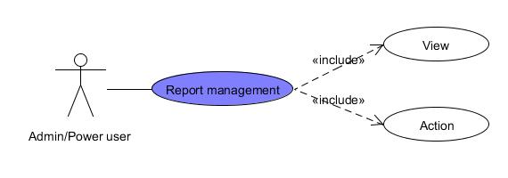

* + - 1. View report

|  |  |  |  |  |
| --- | --- | --- | --- | --- |
| **USE CASE – View report SPECIFICATION** | | | | |
| Use-case No. | UC12 | Use-case Version | | 1.0 |
| Use-case Name | View report | | | |
| Author | KienBT | | | |
| Date | 02/06/2012 | Priority | High | |
| **Actor:**  Admin / Power user  **Summary:**  When user see bad content or spam recipe, comment or recipe. He/she can report bad content to Admin. And Admin or Power User will view all reports to make a decision for a better website.  **Goal**  Admin or power user can view report  **Triggers**  Click to “Report Management” menu then click to “View” sub menu  **Preconditions:**  Logged into website with Admin or Power user role successfully.  **Post Conditions:**  N/A  **Main Success Scenario:**   |  |  |  | | --- | --- | --- | | Step | Actor Action | System Response | | 1 | Click to “Report Management” menu then click to “View” sub menu | Navigate admin to the page with list of existed report |   **Alternative Scenario:**  N/A  **Exceptions:**  N/A  **Relationships:**  Login use case  **Business Rules:**  Must be admin or power user to view all reports | | | | |

* + - 1. Action

|  |  |  |  |  |
| --- | --- | --- | --- | --- |
| **USE CASE - Action SPECIFICATION** | | | | |
| Use-case No. | UC13 | Use-case Version | | 1.0 |
| Use-case Name | Action | | | |
| Author | KienBT | | | |
| Date | 02/06/2012 | Priority | High | |
| **Actor:**  Admin / Power user  **Summary:**  When user see bad content or spam recipe, comment or recipe. He/she can report bad content to Admin. And Admin or Power User will view all reports to make a decision for a better website.  **Goal**  Admin or power user can view report  **Triggers**  Click to “Report Management” menu then click to “View” sub menu  **Preconditions:**  Logged into website with Admin or Power user role successfully.  **Post Conditions:**  N/A  **Main Success Scenario:**   |  |  |  | | --- | --- | --- | | Step | Actor Action | System Response | | 1 | Click to “Report Management” menu then click to categories report sub menu | Navigate admin to the page with list of existed report with corresponding category. | | 2 | Click to “Delete” button | Pop-up window show to confirm delete this report | | 3 | Click to “Yes” button | Comment will be deleted and display message “Spam content and attached reports has been successfully” |   **Alternative Scenario:**   |  |  |  | | --- | --- | --- | | Step | Actor Action | System Response | | 1 | Click to “Report Management” menu then click to categories report sub menu | Navigate admin to the page with list of existed report with corresponding category. | | 2 | Click to “Not spam” button | The report will be deleted and display message “Reports attached to chosen Comment has been deleted successfully” |   **Exceptions:**  N/A  **Relationships:**  Login use case  **Business Rules:**  Must be admin or power user to view all reports | | | | |

#### Approval

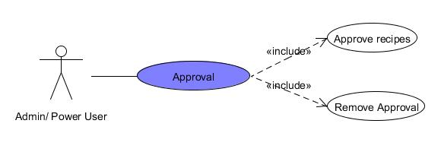

* + - 1. Approve Recipes

|  |  |  |  |  |
| --- | --- | --- | --- | --- |
| **USE CASE – Approve recipes SPECIFICATION** | | | | |
| Use-case No. | UC014 | Use-case Version | | 1.0 |
| Use-case Name | Approve recipe | | | |
| Author | KienBT | | | |
| Date | 02/06/2012 | Priority | High | |
| **Actor:**  Admin / Power user  **Summary:**  When user posts a recipe, it will be showed to the website immediately; However, that is user’s opinion or knowledge. Admin or Power User wants to view posted recipes and approve it with agreement of famous chefs or cooking experts. Recipes were approved that it is high quality recipe and star as “Editor choice”  **Goal**  Admin or power user can approve posted recipes  **Triggers**  Click to “Recipe Management” menu then click to “View” sub menu  **Preconditions:**  Logged into website with Admin or Power user role successfully.  **Post Conditions:**  N/A  **Main Success Scenario:**   |  |  |  | | --- | --- | --- | | Step | Actor Action | System Response | | 1 | Click to “Recipe Management” menu then click to “View” sub menu | Navigate user to the page with list of existed recipes | | 2 | Click recipe want to approve. | Navigate user to the page with corresponding recipe | | 3 | Click “Approve” button | Display message “Recipe approved” |   **Alternative Scenario:**  N/A  **Exceptions:**  N/A  **Relationships:**  Login use case  **Business Rules:**  Must be admin or power user to view for experts and chefs to approve | | | | |

* + - 1. Remove Recipes

|  |  |  |  |  |
| --- | --- | --- | --- | --- |
| **USE CASE – Remove recipes SPECIFICATION** | | | | |
| Use-case No. | UC015 | Use-case Version | | 1.0 |
| Use-case Name | Remove recipes | | | |
| Author | KienBT | | | |
| Date | 02/06/2012 | Priority | High | |
| **Actor:**  Admin / Power user  **Summary:**  Admin or Power User wants to remove approved recipes to unapproved recipes.  **Goal**  Admin or power user can approve posted recipes  **Triggers**  Click to “Recipe Management” menu then click to “View” sub menu  **Preconditions:**  Logged into website with Admin or Power user role successfully.  **Post Conditions:**  N/A  **Main Success Scenario:**   |  |  |  | | --- | --- | --- | | Step | Actor Action | System Response | | 1 | Click to “Recipe Management” menu then click to “View” sub menu | Navigate user to the page with list of existed recipes | | 2 | Click recipe want to approve. | Navigate user to the page with corresponding recipe | | 3 | Click “Remove” button | Display message “Recipe unapproved.” |   **Alternative Scenario:**  N/A  **Exceptions:**  N/A  **Relationships:**  Login use case  **Business Rules:**  Must be admin or power user to view for experts and chefs to remove | | | | |

#### Dictionary Management

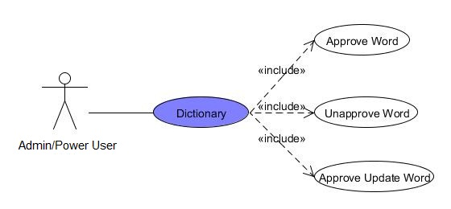

* + - 1. Approve Word

|  |  |  |  |  |
| --- | --- | --- | --- | --- |
| **USE CASE – Approve Word SPECIFICATION** | | | | |
| Use-case No. | UC016 | Use-case Version | | 1.0 |
| Use-case Name | Approve Word | | | |
| Author | KienBT | | | |
| Date | 02/06/2012 | Priority | High | |
| **Actor:**  Admin / Power User  **Summary:**  Admin can approve word and its meaning to show in website.  **Goal**  Only approved word can show in website for user’s searching.  **Triggers**  Click to “Approve Words” hyperlink in Dictionary button on Admin menu bar.  **Preconditions:**  Logged into website successfully with Admin or Power account  **Post Conditions:**  N/A  **Main Success Scenario:**   |  |  |  | | --- | --- | --- | | Step | Actor Action | System Response | | 1 | Click to “Approve” button | System will ask to confirm | | 2 | Click “Yes” | Record will be deleted and display message “Word has been approved successfully” |   **Alternative Scenario:**  N/A  **Exceptions:**   |  |  |  | | --- | --- | --- | | Step | Actor Action | System Response | | 1 | Click to “Approve” button | System will ask you to confirm | | 2 | Click “No” | Navigate to current page with waiting words list for approval. |   **Relationships:**  Login function  **Business Rules:**  Must be Admin/Power User to perform this task. | | | | |

* + - 1. Unapprove Word

|  |  |  |  |  |
| --- | --- | --- | --- | --- |
| **USE CASE – Unapprove Word SPECIFICATION** | | | | |
| Use-case No. | UC017 | Use-case Version | | 1.0 |
| Use-case Name | Unapprove Word | | | |
| Author | KienBT | | | |
| Date | 02/06/2012 | Priority | High | |
| **Actor:**  Admin / Power User  **Summary:**  Admin can unapprove word and its meaning to appear in website.  **Goal**  Uapproved words no longer appear in website for user’s searching.  **Triggers**  Click to “Unpprove Words” hyperlink in Dictionary button on Admin menu bar.  **Preconditions:**  Logged into website successfully with Admin or Power account  **Post Conditions:**  N/A  **Main Success Scenario:**   |  |  |  | | --- | --- | --- | | Step | Actor Action | System Response | | 1 | Click to “Unapprove” button | System will ask to confirm | | 2 | Click “Yes” | Record will be deleted and display message “Word has been unapproved successfully” and move word to approve word page. |   **Alternative Scenario:**  N/A  **Exceptions:**   |  |  |  | | --- | --- | --- | | Step | Actor Action | System Response | | 1 | Click to “Unapprove” button | System will ask you to confirm | | 2 | Click “No” | Navigate to current page with words has been approved. |   **Relationships:**  Login function  **Business Rules:**  Must be Admin/Power User to perform this task. | | | | |

* + - 1. Approve Update Word

|  |  |  |  |  |
| --- | --- | --- | --- | --- |
| **USE CASE – Approve Update Word SPECIFICATION** | | | | |
| Use-case No. | UC018 | Use-case Version | | 1.0 |
| Use-case Name | Approve Update Word | | | |
| Author | KienBT | | | |
| Date | 02/06/2012 | Priority | High | |
| **Actor:**  Admin / Power User  **Summary:**  Admin can approve updating word and its meaning to show in website.  **Goal**  Updating words and meaning for more correctly satisfy user’s searching.  **Triggers**  Click to “Approve Update Words” hyperlink in Dictionary button on Admin menu bar.  **Preconditions:**  Logged into website successfully with Admin or Power account  **Post Conditions:**  N/A  **Main Success Scenario:**   |  |  |  | | --- | --- | --- | | Step | Actor Action | System Response | | 1 | Click to “Approve” button | System will ask to confirm | | 2 | Click “Yes” | Record will be deleted and display message “Word has been approved successfully” |   **Alternative Scenario:**  N/A  **Exceptions:**   |  |  |  | | --- | --- | --- | | Step | Actor Action | System Response | | 1 | Click to “Approve” button | System will ask you to confirm | | 2 | Click “No” | Navigate to current page with waiting words list for approval. |   **Relationships:**  Login function  **Business Rules:**  Must be Admin/Power User to perform this task. | | | | |

### Front – end

#### Account Information

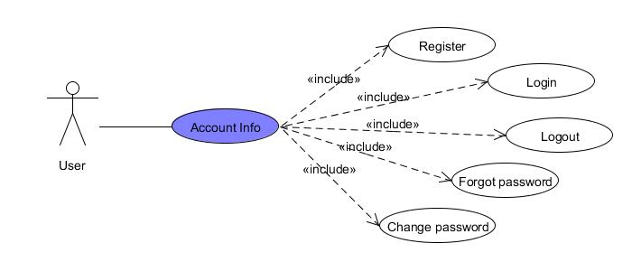

* + - 1. Register Account

|  |  |  |  |  |
| --- | --- | --- | --- | --- |
| **USE CASE – Register Account SPECIFICATION** | | | | |
| Use-case No. | UC14 | Use-case Version | | 1.0 |
| Use-case Name | Register account | | | |
| Author | KienBT | | | |
| Date | 02/06/2012 | Priority | High | |
| **Actor:**  Anonymous user  **Summary:**  Anonymous user can register with real personal information to become an authenticated user.  **Goal:**  Anonymous user became authenticated user  **Triggers**  Click to “Đăng kí thành viên” button on log in area at top right corner of the website  **Preconditions:**  Access to the website  **Post Conditions:**  Navigate the user back to home page.  **Main Success Scenario:**   |  |  |  | | --- | --- | --- | | Step | Actor Action | System Response | | 1 | Click to “Đăng kí” button on log in area at top right corner of the website | Website navigate the user to register page | | 2 | Enter value in required textboxes correctly |  | | 6 | Click to “Đăng kí” button | Send activation email to registered email address and redirect to Success page with some information about user |   **Alternative Scenario:**  N/A  **Exceptions:**   |  |  |  | | --- | --- | --- | | Step | Actor Action | System Response | | 1 | Click to “Đăng kí” button on log in area at top right corner of the website | Website navigate the user to register page | | 2 | Enter wrong value in required textboxes |  | | 3 | Click to “Đăng kí” button | Display error message”Bạn hãy sửa những lỗi bên dưới và thử lại.” |   **Relationships:**  N/A  **Business Rules:**   |  |  |  | | --- | --- | --- | | No | Rule Description | Error Message | | 1 | In order to register a new account, email address, password and confirm password is required. |  | | 2 | One email address can only be used for registering once |  | | | | | |

* + - 1. Login

|  |  |  |  |  |
| --- | --- | --- | --- | --- |
| **USE CASE - Login SPECIFICATION** | | | | |
| Use-case No. | UC15 | Use-case Version | | 1.0 |
| Use-case Name | Login | | | |
| Author | KienBT | | | |
| Date | 02/06/2012 | Priority | High | |
| **Actor:**  Authenticated User  **Summary:**  Authenticated user and manager must be login to website to be able do their function such as post, comment.  **Goal**  Logged in to system  **Triggers**  Click to “Đăng nhập” button  **Preconditions:**  N/A  **Post Conditions:**  N/A  **Main Success Scenario:**   |  |  |  | | --- | --- | --- | | Step | Actor Action | System Response | | 1 | Enter account and password | Redirect user to log in page | | 2 | Click to “Đăng nhập” button | Navigate the user back to previous page |   **Alternative Scenario:**  N/A  **Exceptions:**   |  |  |  | | --- | --- | --- | | Step | Actor Action | System Response | | 1 | Click to “Đăng nhập” at log in area on top right corner of the website | Redirect user to log in page | | 2 | Enter wrong user name, password |  | | 3 | Click to “Đăng nhập” button | Show error message “Bạn hãy sửa những lỗi bên dưới và thử lại. |   **Relationships:**  N/A  **Business Rules:**  Authenticated users enter account and password correctly. | | | | |

* + - 1. Logout

|  |  |  |  |  |
| --- | --- | --- | --- | --- |
| **USE CASE - Logout SPECIFICATION** | | | | |
| Use-case No. | UC16 | Use-case Version | | 1.0 |
| Use-case Name | Logout | | | |
| Author | KienBT | | | |
| Date | 02/06/2012 | Priority | High | |
| **Actor:**  Authenticated User  **Summary:**  Authenticated user logout from website  **Goal**  Logged out from system  **Triggers**  N/A  **Preconditions:**  Logged into website  **Post Conditions:**  N/A  **Main Success Scenario:**   |  |  |  | | --- | --- | --- | | Step | Actor Action | System Response | | 1 | Click to “Thoát” button at top right corner of the website | Redirect to current page and view website as anonymous user. |   **Alternative Scenario:**  N/A  **Exceptions:**  N/A  **Relationships:**  Login function  **Business Rules:**  N/A | | | | |

* + - 1. Forgot password

|  |  |  |  |  |
| --- | --- | --- | --- | --- |
| **USE CASE – Forgot password SPECIFICATION** | | | | |
| Use-case No. | UC17 | Use-case Version | | 1.0 |
| Use-case Name | Forgot password | | | |
| Author | KienBT | | | |
| Date | 02/06/2012 | Priority | High | |
| **Actor:**  Authenticated User  **Summary:**  System will send the forgotten password to email.  **Goal**  User receives forgotten password from system.  **Triggers**  Click “Quên mật khẩu” button  **Preconditions:**  N/A  **Post Conditions:**  Password will be sent to user’s email.  **Main Success Scenario:**   |  |  |  | | --- | --- | --- | | Step | Actor Action | System Response | | 1 | Enter user email |  | | 2 | Click “Quên mật khẩu” button | Display a message “Mật khẩu của bạn đã được gửi vào email” |   **Alternative Scenario:**  N/A  **Exceptions:**   |  |  |  | | --- | --- | --- | | Step | Actor Action | System Response | | 1 | Enter invalid email |  | | 2 | Click “Quên mật khẩu” button | Display a message “Email là bắt buộc” |   **Relationships:**  N/A  **Business Rules:**  User must enter correct email and captcha | | | | |

* + - 1. Change password

|  |  |  |  |  |
| --- | --- | --- | --- | --- |
| **USE CASE – Change password SPECIFICATION** | | | | |
| Use-case No. | UC18 | Use-case Version | | 1.0 |
| Use-case Name | Change password | | | |
| Author | KienBT | | | |
| Date | 02/06/2012 | Priority | Normal | |
| **Actor:**  Authenticated User  **Summary:**  For security, many users often change their account password each 2-3 months. User can change their password by go to their user profile and click to “Đổi mật khẩu” hyperlink  **Goal**  Change password successfully  **Triggers**  Click to “Đổi mật khẩu” hyperlink  **Preconditions:**  Logged into website successfully.  **Post Conditions:**  Stay remains at forgot pass page  **Main Success Scenario:**   |  |  |  | | --- | --- | --- | | Step | Actor Action | System Response | | 1 | Click to “Đổi mật khẩu” button | Navigate user to change password page | | 2 | Enter required fields |  | | 3 | Click to “Lưu” button | Display message “Đổi mật khẩu thành công” |   **Alternative Scenario:**  N/A  **Exceptions:**   |  |  |  | | --- | --- | --- | | Step | Actor Action | System Response | | 1 | Click to “Lưu” button | Display message “Bạn hãy sửa những lỗi bên dưới và thử lại.” |   **Relationships:**  N/A  **Business Rules:**  Old password, new password and confirm password are required to change password | | | | |

#### Comment

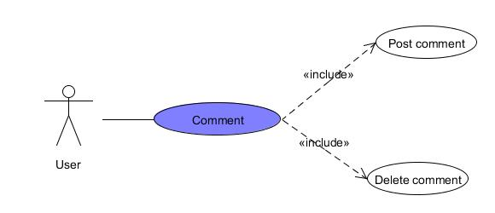

* + - 1. Post comment

|  |  |  |  |  |
| --- | --- | --- | --- | --- |
| **USE CASE – Post comment SPECIFICATION** | | | | |
| Use-case No. | UC19 | Use-case Version | | 1.0 |
| Use-case Name | Post comment | | | |
| Author | KienBT | | | |
| Date | 02/06/2012 | Priority | High | |
| **Actor:**  Authenticated User  **Summary:**  When users want to express his/her opinion about recipes or tips.  **Goal**  User post comment successfully.  **Triggers**  Click “bình luận” textbox  **Preconditions:**  Logged into website successfully.  **Post Conditions:**  Stay remain at current recipe page with a comment was added.  **Main Success Scenario:**   |  |  |  | | --- | --- | --- | | Step | Actor Action | System Response | | 1 | Click to “bình luận” textbox and type comment |  | | 2 | Click “Bình luận” button | Stay remains current page with new comment is posted |   **Alternative Scenario:**  N/A  **Exceptions:**   |  |  |  | | --- | --- | --- | | Step | Actor Action | System Response | | 1 | Click to “bình luận” textbox and type comment |  | | 2 | Click “Bình luận” button | Display a message “Bình luận không hợp lệ.” |   **Relationships:**  N/A  **Business Rules:**  Comment must be greater than 0 characters. | | | | |

* + - 1. Delete comment

|  |  |  |  |  |
| --- | --- | --- | --- | --- |
| **USE CASE – Delete comment SPECIFICATION** | | | | |
| Use-case No. | UC20 | Use-case Version | | 1.0 |
| Use-case Name | Delete comment | | | |
| Author | KienBT | | | |
| Date | 02/06/2012 | Priority | Normal | |
| **Actor:**  Authenticated User  **Summary:**  When users want to delete his/her comments.  **Goal**  User deletes comments.  **Triggers**  Click to posted comments.  **Preconditions:**  Logged into website successfully.  **Post Conditions:**  Stay remain at current recipe page with a comment was deleted.  **Main Success Scenario:**   |  |  |  | | --- | --- | --- | | Step | Actor Action | System Response | | 1 | Click “X” on comment textbox | Stay remains current page with comment was deleted. |   **Alternative Scenario:**  N/A  **Exceptions:**  N/A  **Relationships:**  N/A  **Business Rules:**  Must be your comments. | | | | |

#### Create

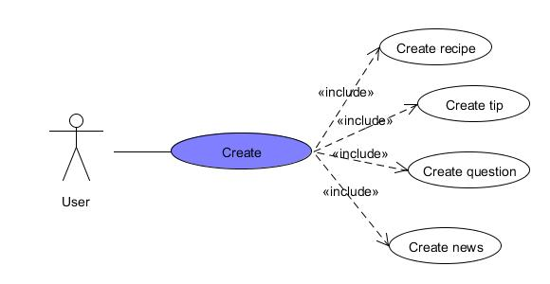

* + - 1. Create recipe

|  |  |  |  |  |
| --- | --- | --- | --- | --- |
| **USE CASE – Create Recipe SPECIFICATION** | | | | |
| Use-case No. | UC21 | Use-case Version | | 1.0 |
| Use-case Name | Create recipe | | | |
| Author | KienBT | | | |
| Date | 02/06/2012 | Priority | Normal | |
| **Actor:**  Authenticated User  **Summary:**  When user wants to post a recipe to sharing with other people.  **Goal**  User follows the form to post recipes easily and rapidly  **Triggers**  Move mouse to “Gửi bài” and click to “Gửi công thức” hyperlink  **Preconditions:**  Logged into website successfully.  **Post Conditions:**  Stay remain at current recipe page with a new recipe was posted.  **Main Success Scenario:**   |  |  |  | | --- | --- | --- | | Step | Actor Action | System Response | | 1 | Click to “ Gửi công thức” hyperlink | Navigate user to the page has form to user fills. | | 2 | Enter required fields |  | | 3 | Click to “ Chọn ảnh” button | Dialog opens to choose picture | | 4 | Click to “Lưu” button | Navigate user to page includes the recipe what has just posted. |   **Alternative Scenario:**  N/A  **Exceptions:**   |  |  |  | | --- | --- | --- | | Step | Actor Action | System Response | | 1 | Click to “ Gửi công thức” hyperlink | Navigate user to the page has form to user fills. | | 2 | Leave required fields blank |  | | 3 | Click to “ Gửi” button | Display a message “Bạn hãy sửa những lỗi bên dưới và thử lại”. |   **Relationships:**  Login function  **Business Rules:**  Must have main picture and description about dish | | | | |

* + - 1. Create tip

|  |  |  |  |  |
| --- | --- | --- | --- | --- |
| **USE CASE – Create tip SPECIFICATION** | | | | |
| Use-case No. | UC22 | Use-case Version | | 1.0 |
| Use-case Name | Create tip | | | |
| Author | KienBT | | | |
| Date | 02/06/2012 | Priority | Normal | |
| **Actor:**  Authenticated User  **Summary:**  When user wants to post a tip for collecting better ingredients or cooking more delicious.  **Goal**  User creates tip successfully  **Triggers**  Click to “Mẹo vặt” hyperlink  **Preconditions:**  Logged into website successfully.  **Post Conditions:**  Stay remain at current recipe page with a new tip was posted.  **Main Success Scenario:**   |  |  |  | | --- | --- | --- | | Step | Actor Action | System Response | | 1 | Click to “Gửi” button | Navigate user to the page has form to user fills. | | 2 | Enter required fields |  | | 3 | Click to “Chọn ảnh” button | Dialog opens to choose picture | | 4 | Click to “Gửi” button | Navigate user to page includes the tip what has just posted. |   **Alternative Scenario:**  N/A  **Exceptions:**   |  |  |  | | --- | --- | --- | | Step | Actor Action | System Response | | 1 | Click to “Gửi” button | Navigate user to the page has form to user fills. | | 2 | Leave required fields blank |  | | 3 | Click to “Gửi” button | Show error message “Bạn hãy sửa những lỗi bên dưới và thử lại.” |   **Relationships:**  Login function  **Business Rules:**  Description must be greater than 10 characters. | | | | |

* + - 1. Create news

|  |  |  |  |  |
| --- | --- | --- | --- | --- |
| **USE CASE – Create news SPECIFICATION** | | | | |
| Use-case No. | UC23 | Use-case Version | | 1.0 |
| Use-case Name | Create news | | | |
| Author | KienBT | | | |
| Date | 02/06/2012 | Priority | Normal | |
| **Actor:**  Authenticated User  **Summary:**  When user wants to post news related to cooking.  **Goal**  User posts news such as ingredients price or health news…  **Triggers**  Click to “Tin tức” hyperlink  **Preconditions:**  Logged into website successfully.  **Post Conditions:**  Stay remain at current recipe page with new news was posted.  **Main Success Scenario:**   |  |  |  | | --- | --- | --- | | Step | Actor Action | System Response | | 1 | Click to “ Gửi” button | Navigate user to the page has form to user fills. | | 2 | Enter required fields |  | | 3 | Click to “Chọn ảnh” button | Dialog opens to choose picture | | 4 | Click to “Gửi” button | Navigate user to page includes the tip what has just posted. |   **Alternative Scenario:**  N/A  **Exceptions:**   |  |  |  | | --- | --- | --- | | Step | Actor Action | System Response | | 1 | Click to “Gửi” button | Navigate user to the page has form to user fills. | | 2 | Leave required fields blank |  | | 3 | Click to “Chọn ảnh” button | Dialog opens to choose picture | | 4 | Click to “ Gửi” button | Show error message “Bạn hãy sửa những lỗi bên dưới và thử lại.” |   **Relationships:**  Login function  **Business Rules:**  Description must be greater than 10 characters. | | | | |

* + - 1. Create question

|  |  |  |  |  |
| --- | --- | --- | --- | --- |
| **USE CASE – Create question SPECIFICATION** | | | | |
| Use-case No. | UC24 | Use-case Version | | 1.0 |
| Use-case Name | Create question | | | |
| Author | KienBT | | | |
| Date | 02/06/2012 | Priority | Normal | |
| **Actor:**  Authenticated User  **Summary:**  When users want to ask something related to cooking.  **Goal**  User creates question for other users when he/she wants to ask something.  **Triggers**  Click to “Hỏi đáp” hyperlink  **Preconditions:**  Logged into website successfully.  **Post Conditions:**  Stay remain at current recipe page with new question was asked.  **Main Success Scenario:**   |  |  |  | | --- | --- | --- | | Step | Actor Action | System Response | | 1 | Click to “Gửi câu hỏi” hyperlink |  | | 2 | Enter required fields |  | | 3 | Click “Gửi” button | Stay remains current page with new question was posted |   **Alternative Scenario:**  N/A  **Exceptions:**   |  |  |  | | --- | --- | --- | | Step | Actor Action | System Response | | 1 | Click to “Gửi câu hỏi” hyperlink |  | | 2 | Click “Gửi” button | Display message “Câu hỏi phải ít nhất 10 ký tự” |   **Relationships:**  Login function  **Business Rules:**  Description must be greater than 10 characters. | | | | |

#### Personal Information

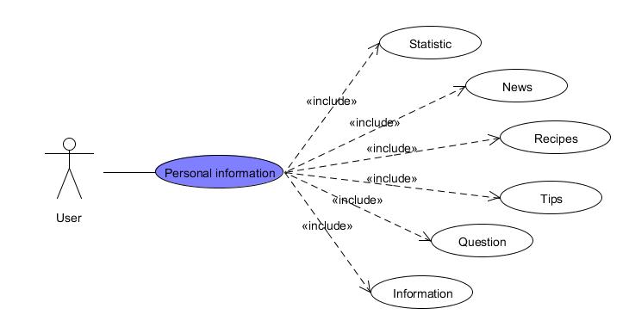

* + - 1. Edit personal information

|  |  |  |  |  |
| --- | --- | --- | --- | --- |
| **USE CASE – Edit personal information SPECIFICATION** | | | | |
| Use-case No. | UC25 | Use-case Version | | 1.0 |
| Use-case Name | Edit personal information | | | |
| Author | KienBT | | | |
| Date | 02/06/2012 | Priority | High | |
| **Actor:**  Authenticated User  **Summary:**  When user sees something wrong in his/her information, user can edit personal information.  **Goal**  Edit account information  **Triggers**  Click to “Trang cá nhân” hyperlink  **Preconditions:**  Logged into website successfully.  **Post Conditions:**  N/A  **Main Success Scenario:**   |  |  |  | | --- | --- | --- | | Step | Actor Action | System Response | | 1 | Click to “Sửa thông tin” hyperlink | Navigate user to his/her information to edit | | 2 | Edit information |  | | 3 | Click “Đổi ảnh đại diện” and choose another picture |  | | 4 | Click “Lưu” button | Display user information |   **Alternative Scenario:**  N/A  **Exceptions:**   |  |  |  | | --- | --- | --- | | Step | Actor Action | System Response | | 1 | Click to “Lưu” button | Display message “Bạn hãy sửa những lỗi bên dưới và sửa lại” |   **Relationships:**  View user’s profile  **Business Rules:**  N/A | | | | |

* + - 1. View Detail Personal Information

|  |  |  |  |  |
| --- | --- | --- | --- | --- |
| **USE CASE – View Detail Personal Information SPECIFICATION** | | | | |
| Use-case No. | UC26 | Use-case Version | | 1.0 |
| Use-case Name | View Detail Personal Information | | | |
| Author | KienBT | | | |
| Date | 02/06/2012 | Priority | Normal | |
| **Actor:**  Authenticated User  **Summary:**  User can view their or other user’s detailed personal information  **Goal**  View detail any user’s detailed account information  **Triggers**  User clicks on username hyperlink to navigate to their personal page.  **Preconditions:**  Logged into website successfully.  **Post Conditions:**  Redirect the user to profile page  **Main Success Scenario:**   |  |  |  | | --- | --- | --- | | Step | Actor Action | System Response | | 1 | Click to other user’s name hyperlink | navigate user to correspond user information |   **Alternative Scenario:**  N/A  **Exceptions:**  N/A  **Relationships:**  Login use case  **Business Rules:**  User Profile page will be opened as user click to a user link on anywhere on the website. This page contains all information about a user. | | | | |

* + - 1. Change Email

|  |  |  |  |  |
| --- | --- | --- | --- | --- |
| **USE CASE – Change Email SPECIFICATION** | | | | |
| Use-case No. | UC27 | Use-case Version | | 1.0 |
| Use-case Name | Change Email | | | |
| Author | KienBT | | | |
| Date | 02/06/2012 | Priority | Normal | |
| **Actor:**  Authenticated User  **Summary:**  For security or change email usage habit, many users want to change their email to manage and protect their account.  **Goal**  Change email to easy to manage account.  **Triggers**  Click to “Đổi Email” hyperlink  **Preconditions:**  Logged into website successfully.  **Post Conditions:**  N/A  **Main Success Scenario:**   |  |  |  | | --- | --- | --- | | **Step** | **Actor Action** | **System Response** | | 1 | Click to “Đổi email” hyperlink | navigate user to change email page | | 2 | Enter new email |  | | 3 | Click to “Lưu” button | Display message “Đổi email thành công” |   **Alternative Scenario:**  N/A  **Exceptions:**   |  |  |  | | --- | --- | --- | | **Step** | **Actor Action** | **System Response** | | 1 | Click to “Đổi email” hyperlink | navigate user to change email page | | 2 | Enter wrong required information |  | | 3 | Click to “Lưu” button | Display message “Bạn hãy sửa những lõi bên dưới và thử lại.” |   **Relationships:**  N/A  **Business Rules:**  N/A | | | | |

#### Question & Answer

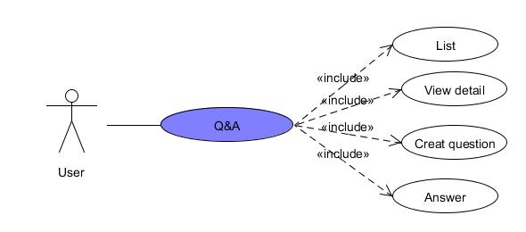

* + - 1. List Question

|  |  |  |  |  |
| --- | --- | --- | --- | --- |
| **USE CASE – List Question SPECIFICATION** | | | | |
| **Use-case No.** | UC28 | **Use-case Version** | | 1.0 |
| **Use-case Name** | List Question | | | |
| **Author** | ToanDX | | | |
| **Date** | 02/06/2012 | **Priority** | High | |
| **Actor:**  User  **Summary:**  This Question Page displays all questions of users. If user doesn’t find what they want, he/she can post a new question by clicks to “Gửi câu hỏi mới” hyperlink. Besides, all questions are displayed in question page will be displayed with question title, creator name, created time, number of vote up and vote down, number of views and answers. In default, Q&A will display 10 questions. User need click to “Xem thêm” to view more questions.  **Goal:**  Display Q&A page  **Triggers**  Click to “Hỏi đáp” menu bar.  **Preconditions:**  Access the website.  **Post Conditions:**  Stay remains at current page with Q&A page displayed.  **Main Success Scenario:**   |  |  |  | | --- | --- | --- | | Step | Actor Action | System Response | | 1 | Click to “Hỏi đáp” menu bar | Redirect user to Q&A page and displays questions. |   **Alternative Scenario:**  N/A  **Exceptions:**  N/A  **Relationships:**  N/A  **Business Rules:**  N/A | | | | |

* + - 1. View Detail

|  |  |  |  |  |
| --- | --- | --- | --- | --- |
| **USE CASE – View Question Detail SPECIFICATION** | | | | |
| **Use-case No.** | UC28 | **Use-case Version** | | 1.0 |
| **Use-case Name** | View Question Detail | | | |
| **Author** | ToanDX | | | |
| **Date** | 02/06/2012 | **Priority** | Normal | |
| **Actor:**  User  **Summary:**  When the users click on any question link, they will be redirected to corresponding question detail page. It contains question and its answers.  **Goal:**  Display question’s detail.  **Triggers**  Click to question’s detail hyperlink.  **Preconditions:**  Access the website.  **Post Conditions:**  Question and its answers will be displayed.  **Main Success Scenario:**   |  |  |  | | --- | --- | --- | | Step | Actor Action | System Response | | 1 | Click to question hyperlink | Redirect to question detail page |   **Alternative Scenario:**   |  |  |  | | --- | --- | --- | | Step | Actor Action | System Response | | 1 | User creates a new question and click to “Gửi” button. | Redirect to question detail page |   **Exceptions:**  N/A  **Relationships:**  Login use case, Create a New Question use case  **Business Rules:**  N/A | | | | |

* + - 1. Create Question

|  |  |  |  |  |
| --- | --- | --- | --- | --- |
| **USE CASE – Create New question SPECIFICATION** | | | | |
| **Use-case No.** | UC29 | **Use-case Version** | | 1.0 |
| **Use-case Name** | Create New Question | | | |
| **Author** | ToanDX | | | |
| **Date** | 02/06/2012 | **Priority** | Normal | |
| **Actor:**  User  **Summary:**  When users come to Q&A page and cannot find any question which suitable for their need, they can post a new question to find a solution for their problem.  **Goal:**  Create a new question.  **Triggers**  Click to “Gửi câu hỏi mới” hyperlink.  **Preconditions:**  Successfully logged into the system and accessed to question page.  **Post Conditions:**  Redirect to Question Detail page.  **Main Success Scenario:**   |  |  |  | | --- | --- | --- | | Step | Actor Action | System Response | | 1 | Click to “Gửi câu hỏi mới” hyperlink | Redirect user to Create new question page | | 2 | Enter required fields |  | | 3 | Click to “Gửi” button | Website will redirect to Question Detail page |   **Alternative Scenario:**  N/A  **Exceptions:**   |  |  |  | | --- | --- | --- | | Step | Actor Action | System Response | | 1 | Click to “Gửi câu hỏi mới” hyperlink | Redirect user to Create new question page | | 2 | Click to “Gửi” button | Display message “Bạn hãy sửa những lỗi bên dưới và thử lại.” |   **Relationships:**  Login use case, question page use case  **Business Rules:**  N/A | | | | |

* + - 1. Answer Question

|  |  |  |  |  |
| --- | --- | --- | --- | --- |
| **USE CASE – Answer Question SPECIFICATION** | | | | |
| **Use-case No.** | UC30 | **Use-case Version** | | 1.0 |
| **Use-case Name** | Answer Question | | | |
| **Author** | ToanDX | | | |
| **Date** | 02/06/2012 | **Priority** | Normal | |
| **Actor:**  User  **Summary:**  When open question page, the user can realize a question that he/she knows the answer or it is same problem with the user problem. The user can post an answer to propose a solution or showing empathy with the asker.  **Goal:**  Allow user to post an answer.  **Triggers**  Click to “Trả lời” button.  **Preconditions:**  Successfully logged in to the system and accessed to question detail page.  **Post Conditions:**  Stay remains at question detail page with new answer on top of answer area.  **Main Success Scenario:**   |  |  |  | | --- | --- | --- | | Step | Actor Action | System Response | | 1 | Click to the answer text box | “Trả lời” and “Bỏ qua” buttons appear | | 2 | Enter the content in reply box. |  | | 3 | Click to “Trả lời” button | The answer will be added to top of answer area with the content, creator, creator’s avatar and created time. |   **Alternative Scenario:**  N/A  **Exceptions:**   |  |  |  | | --- | --- | --- | | Step | Actor Action | System Response | | 1 | Click to the answer text box | “Trả lời” and “Bỏ qua” buttons appear | | 2 | The user leaves the content blank |  | | 3 | Click to “Trả lời” button | Nothing happen |     **Relationships:**  Login use case and question page use case  **Business Rules:**  N/A | | | | |

#### Rate Content

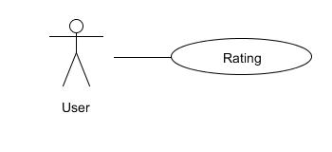

|  |  |  |  |  |
| --- | --- | --- | --- | --- |
| **USE CASE – Rate Content SPECIFICATION** | | | | |
| **Use-case No.** | UC31 | **Use-case Version** | | 1.0 |
| **Use-case Name** | Rate Content | | | |
| **Author** | ToanDX | | | |
| **Date** | 02/06/2012 | **Priority** | High | |
| **Actor:**  User  **Summary:**  When the user views information of a recipe, he/she can rate it based on the usefulness of the information or his/her opinion. The user only need move the mouse to the thumb up or thumb down icon to choose.  **Goal:**  Thumb up or thumb down content.  **Triggers**  Click to rating bar (1 to 5 stars) with recipes or click to thumb up or thumb down icon with tips and questions/answers.  **Preconditions:**  Successfully logged into the system and open a content detail page.  **Post Conditions:**  Stay remains at current content detail page with a rating saved.  **Main Success Scenario:**   |  |  |  | | --- | --- | --- | | Step | Actor Action | System Response | | 1 | Click to star (1 to 5 stars) to rate recipes | Star’s color will change from white to yellow and display message “Cảm ơn bạn đã đánh giá công thức nấu ăn này.” |   **Alternative Scenario:**   |  |  |  | | --- | --- | --- | | Step | Actor Action | System Response | | 1 | Click to thumb up or thumb down icon ( for tips and questions/answers) | Rating is saved and displayed by number of thumb up or thumb down |   **Exceptions:**  N/A  **Relationships:**  Log in use case.  **Business Rules:**  N/A | | | | |

#### Favorite List

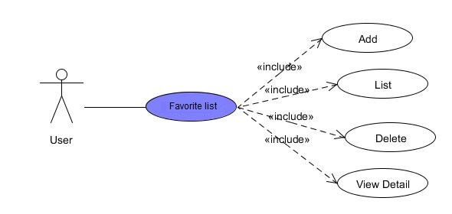

* + - 1. Add ContentTo Favorite List

|  |  |  |  |  |
| --- | --- | --- | --- | --- |
| **USE CASE – Add Content To Favorite List SPECIFICATION** | | | | |
| **Use-case No.** | UC32 | **Use-case Version** | | 1.0 |
| **Use-case Name** | Add ContentTo Favorite List | | | |
| **Author** | ToanDX | | | |
| **Date** | 02/06/2012 | **Priority** | Normal | |
| **Actor:**  User  **Summary:**  When using website, maybe user will find out some interesting contents and want to save them for using later. So this function is really useful for them.  **Goal:**  Users can add contents to their favorite list.  **Triggers**  Click to “Thêm vào sổ tay” button.  **Preconditions:**  Successfully logged into the system and open a content detail page.  **Post Conditions:**  Stay remains at Content Detail page.  **Main Success Scenario:**   |  |  |  | | --- | --- | --- | | Step | Actor Action | System Response | | 1 | Click to “Thêm vào sổ tay” button | Display message “Công thức nấu ăn đã được thêm vào sổ tay.” |   **Alternative Scenario:**  N/A  **Exceptions:**  N/A  **Relationships:**  Login use case  **Business Rules:**  N/A | | | | |

* + - 1. Favorite List

|  |  |  |  |  |
| --- | --- | --- | --- | --- |
| **USE CASE – Favorite List SPECIFICATION** | | | | |
| **Use-case No.** | UC33 | **Use-case Version** | | 1.0 |
| **Use-case Name** | Favorite List | | | |
| **Author** | ToanDX | | | |
| **Date** | 02/06/2012 | **Priority** | Normal | |
| **Actor:**  User  **Summary:**  When using website, maybe user will find out some interesting contents and want to save for using later. Favorite List will help user to manage favorite contents.  **Goal:**  Display list of contents which user favor.  **Triggers**  Click to “Sổ tay” hyperlink at user profile page.  **Preconditions:**  Successfully logged into the system and go to your profile page.  **Post Conditions:**  “Sổ tay” page is displayed with all favorite contents.  **Main Success Scenario:**   |  |  |  | | --- | --- | --- | | Step | Actor Action | System Response | | 1 | Click to “Sổ tay” hyperlink | “Sổ tay” page is displayed with all favorite contents |   **Alternative Scenario:**  N/A  **Exceptions:**  N/A  **Relationships:**  Login use case  **Business Rules:**  N/A | | | | |

* + - 1. Delete Content From Favorite List

|  |  |  |  |  |
| --- | --- | --- | --- | --- |
| **USE CASE – Delete Content From Favorite List SPECIFICATION** | | | | |
| **Use-case No.** | UC34 | **Use-case Version** | | 1.0 |
| **Use-case Name** | Delete Content From Favorite List | | | |
| **Author** | ToanDX | | | |
| **Date** | 02/06/2012 | **Priority** | Normal | |
| **Actor:**  User  **Summary:**  A content which user liked before, but user doesn’t like anymore and want to delete it from favorite list. So he/she can use this function.  **Goal:**  Users can delete any content which existed in their favorite list.  **Triggers**  Click to “Xoá” button.  **Preconditions:**  Successfully logged into the system and accessed to favorite list page.  **Post Conditions:**  Selected content will be deleted from user’s favorite list.  **Main Success Scenario:**   |  |  |  | | --- | --- | --- | | Step | Actor Action | System Response | | 1 | Select check box besides a content which user want to delete. |  | | 2 | Click to “Xóa” button | Selected content is deleted. |   **Alternative Scenario:**   |  |  |  | | --- | --- | --- | | Step | Actor Action | System Response | | 1 | Select check box besides Favorite List title. | All favorite contents are selected. | | 2 | Click to “Xóa” button | All favorite contents are deleted. |   **Exceptions:**  N/A  **Relationships:**  Login use case, View Favorite List use case.  **Business Rules:**  N/A | | | | |

* + - 1. View Detail Favorite Content

|  |  |  |  |  |
| --- | --- | --- | --- | --- |
| **USE CASE – View Detail Favorite Content SPECIFICATION** | | | | |
| **Use-case No.** | UC35 | **Use-case Version** | | <1.0> |
| **Use-case Name** | View Detail Favorite Content | | | |
| **Author** | ToanDX | | | |
| **Date** | 02/06/2012 | **Priority** | Normal | |
| **Actor:**  User  **Summary:**  When the user wants to see a favorite content completely, he/she can view detail of content.  **Goal:**  Display detail of content.  **Triggers**  Click to content’s detail hyperlink.  **Preconditions:**  Successfully logged into the system and accessed to “Sổ tay” page.  **Post Conditions:**  The page navigates to the content’s detail page.  **Main Success Scenario:**   |  |  |  | | --- | --- | --- | | Step | Actor Action | System Response | | 1 | Click to content hyperlink | Redirect to content detail page |   **Alternative Scenario:**  N/A  **Exceptions:**  N/A  **Relationships:**  Login use case, View Favorite List use case, View Content Detail use case.  **Business Rules:**  N/A | | | | |

#### Search

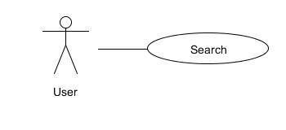

|  |  |  |  |  |
| --- | --- | --- | --- | --- |
| **USE CASE – Search Contents SPECIFICATION** | | | | |
| **Use-case No.** | UC36 | **Use-case Version** | | 1.0 |
| **Use-case Name** | Search Contents | | | |
| **Author** | ToanDX | | | |
| **Date** | 03/06/2012 | **Priority** | High | |
| **Actor:**  User  **Summary:**  Users can search for contents by some criteria in order to find contents suitable for their need. The search result will be filtered to support users find the right contents as quick as possible.  **Goal:**  Search for contents.  **Triggers**  Users enter search criteria and click search button  **Preconditions:**  Access the website  **Post Conditions:**  The page navigates to search result screen with the result displayed  **Main Success Scenario:**   |  |  |  | | --- | --- | --- | | Step | Actor Action | System Response | | 1 | Enter keyword to search text box |  | | 2 | Click to “Chọn danh mục” dropdown list | Show categories for user to choose | | 3 | Click to search icon | Display search result |   **Alternative Scenario:**  N/A  **Alternative Scenario – No result**   |  |  |  | | --- | --- | --- | | Step | Actor Action | System Response | | 1 | Enter keyword which no content has |  | | 2 | Clicks “Tìm kiếm” button | Display “Không tìm kết quả nào.” |   **Exceptions:**  N/A  **Relationships:**  N/A  **Business Rules:**  N/A | | | | |

#### Share Contents

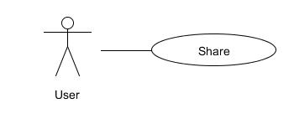

|  |  |  |  |  |
| --- | --- | --- | --- | --- |
| **USE CASE – Share Contents SPECIFICATION** | | | | |
| **Use-case No.** | UC37 | **Use-case Version** | | 1.0 |
| **Use-case Name** | Share Contents | | | |
| **Author** | ToanDX | | | |
| **Date** | 02/06/2012 | **Priority** | Normal | |
| **Actor:**  User  **Summary:**  When the user wants to share content, he/she can do it by share that content over other social networks: Facebook, Twitter, Google+. The user can click social icon button below each contents to share it.  **Goal:**  Share contents over other social networks.  **Triggers**  Click to “Chia sẻ” hyperlink.  **Preconditions:**  Successfully logged into the system and go to detail content page.  **Post Conditions:**  Stay remains at current contents detail page.  **Main Success Scenario:**   |  |  |  | | --- | --- | --- | | Step | Action | System Response | | 1 | Click to “Chia sẻ” hyperlink. | Popup new window: login page or home page (if user login) of Social network they want to share to. | | 2 | Click to social network icon to share (at new popup window). | Close the popup window and content is shared. |   **Exceptions:**   |  |  |  | | --- | --- | --- | | Step | Actor Action | System Response | | 1 | Click to “Chia sẻ” hyperlink. | Popup new window: login page or home page (if user login) of Social network they want to share to. | | 2 | Click to “x” icon (at new popup window). | Close the popup window and content is not shared. |   **Relationships:**  Login use case, View Content Detail use case.  **Business Rules:**  N/A | | | | |

#### Sort Content

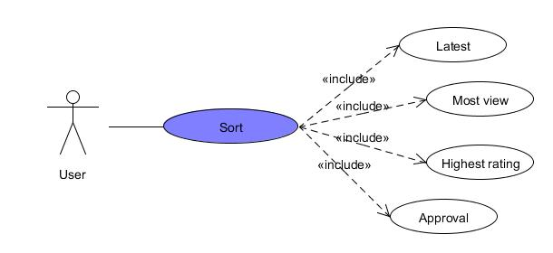

|  |  |  |  |  |
| --- | --- | --- | --- | --- |
| **USE CASE – Sort Content SPECIFICATION** | | | | |
| **Use-case No.** | UC38 | **Use-case Version** | | 1.0 |
| **Use-case Name** | Sort Content | | | |
| **Author** | ToanDX | | | |
| **Date** | 02/06/2012 | **Priority** | Normal | |
| **Actor:**  User  **Summary:**  Users will have the options to sort recipes by rating, number of comments and number of page views. Default will be “rating descending”.  **Goal:**  Sort a content base on user’s desired.  **Triggers**  Click to views/rating/new/approved hyperlink.  **Preconditions:**  Access the website  **Post Conditions:**  Stay remains at current page with contents sorted.  **Main Success Scenario:**   |  |  |  | | --- | --- | --- | | Step | Actor Action | System Response | | 1 | Click to new/views/comment/approved hyperlink. | Contents is sorted by new/views/comments descending and displayed. |   **Alternative Scenario:**  N/A  **Exceptions:**  N/A  **Relationships:**  N/A  **Business Rules:**  N/A | | | | |

#### Personal Contribution

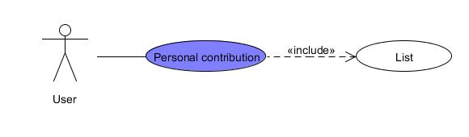

|  |  |  |  |  |
| --- | --- | --- | --- | --- |
| **USE CASE – Personal Contribution SPECIFICATION** | | | | |
| Use-case No. | UC39 | Use-case Version | | 1.0 |
| Use-case Name | List contribution | | | |
| Author | KienBT | | | |
| Date | 02/06/2012 | Priority | Normal | |
| **Actor:**  Authenticated User  **Summary:**  User can list his/her contribution for website  **Goal**  List all contributed post by user.  **Triggers**  Click to “Trang cá nhân” hyperlink  **Preconditions:**  Logged into website successfully.  **Post Conditions:**  N/A  **Main Success Scenario:**   |  |  |  | | --- | --- | --- | | Step | Actor Action | System Response | | 1 | Click to “Trang cá nhân” hyperlink | Show list contributed post (news, recipes and tips) of user |   **Alternative Scenario:**  N/A  **Exceptions:**  N/A  **Relationships:**  View user’s profile  **Business Rules:**  List of contributed post is sorted by date/time. | | | | |

#### Dictionary

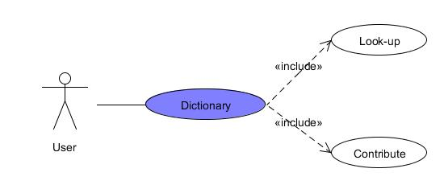

##### 2.2.12.1 Look up

|  |  |  |  |  |
| --- | --- | --- | --- | --- |
| **USE CASE - Dictionary SPECIFICATION** | | | | |
| Use-case No. | UC040 | Use-case Version | | 1.0 |
| Use-case Name | Look-up | | | |
| Author | KienBT | | | |
| Date | 02/06/2012 | Priority | High | |
| **Actor:**  Authenticated User  **Summary:**  User can look-up a strange word and see its meaning  **Goal**  User finds the meaning of a strange or new word.  **Triggers**  Click to “Xem đầy đủ” hyperlink  **Preconditions:**  Logged into website successfully.  **Post Conditions:**  N/A  **Main Success Scenario:**   |  |  |  | | --- | --- | --- | | Step | Actor Action | System Response | | 1 | Click to “Xem đầy đủ” hyperlink on the right of website | Show all words and meanings. |   **Alternative Scenario:**  N/A  **Exceptions:**  N/A  **Relationships:**  Login function  **Business Rules:**  N/A | | | | |

##### 2.2.12.2 Contribute

|  |  |  |  |  |
| --- | --- | --- | --- | --- |
| **USE CASE - Contribute SPECIFICATION** | | | | |
| Use-case No. | UC040 | Use-case Version | | 1.0 |
| Use-case Name | Contribute | | | |
| Author | KienBT | | | |
| Date | 02/06/2012 | Priority | High | |
| **Actor:**  Authenticated User  **Summary:**  User can contribute a strange word and see its meaning  **Goal**  User send a contribution for website.  **Triggers**  Click to “Thêm từ mới” hyperlink on the right of website.  **Preconditions:**  Logged into website successfully.  **Post Conditions:**  N/A  **Main Success Scenario:**   |  |  |  | | --- | --- | --- | | Step | Actor Action | System Response | | 1 | Click to “Từ” textbox, “Nghĩa” textbox and type the word |  | | 2 | Click “Gửi” | Display message “Thêm từ mới thành công. Ban quản trị sẽ kiểm tra độ chính xác trong thời gian sớm nhất.” |   **Alternative Scenario:**  N/A  **Exceptions:**   |  |  |  | | --- | --- | --- | | Step | Actor Action | System Response | | 1 | Leave textboxes blank |  | | 2 | Click “Tìm” button | Display message “Bạn hãy sửa những lỗi bên dưới và thử lại” |   **Relationships:**  Login function  **Business Rules:**  N/A | | | | |

## **Software System Attributes**

### Usability

GUI

* The screen should be clear enough to see even in outside light condition.
* The interface should be simple easy to handle.

Usability for end-users.

* Easy to use. It must take no more than 30 second and a small guide for customer to figure out how to order dishes.

Usability for admin and staff

* Staff should need no more than one day of training to be productive with the system.
* Detailed help must be available for the admin and staff.

Installation

* The system must be easy to deploy. Customer can deploy successfully and learn to configure, maintain the system within one day of training.
* The documentation for installation must be included. It describes detailed steps for installing or deploying the system. The customer can follow the steps without direct help from the developing team.

### Reliability

* System can run probably for a decent amount of time without interrupt.
* The database must be backed up regularly and can be recovered if necessary.
* Have a good sorting algorism to avoid unfair in serving dishes.
* Reliable data transmission.

### Availability

* Systems have to run 24 hours 7 days
* Maintenance required is less than once a month.
* System operate locally base on internal network…

### Security

* N/A

### Maintainability

Using Yakindu to develop the system enable to easily maintain and for further development.

### Portability

The system can be upgrade if necessary .For example, using tablet instead of devices.

### Performance

Response time:

* Every signal transmission must be finished in around 5 second.

Confirmation

* Every signal transmission must have a feedback protocol to prevent signal losses.

Stability

* Any device that using batteries must be able to last at least 24 for a charge.
* The device must be able to withstand the environment. For example: The screen in the kitchen can withstand heat and dampness. If the table are place in the open sky. The devices also need to withstand sunlight and rain.
* The system requires maintaining less than once a month.

Adaptive

* The ordering device should be portable in case of moving table. .
* The system should be able to operate locally with rely on any third party.
* The system should still be stable even if the amount of table in the system increases up to around 50 tables.

# Data Structures

## Data schema

-----

## Folder Structure

-----

## Description

-----

# References